Nashville, Tennessee

The Tennessee Board of Regents for the State University

and Community College System of Tennessee upon the recommendation

of the Faculty hereby confers upon

{{full_name}}

Who has completed the studies and fulfilled all the requirements
set forth by the College for the {{degree}} in

{{major}}
{{concentration}}
{{honors_1}}

in testimony whereof the seal of the State and signatures as authorized by
the Tennessee Board of Regents and hereunto affixed
this {{graduationDate}}
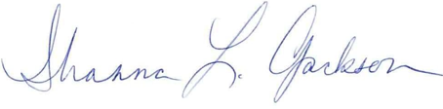

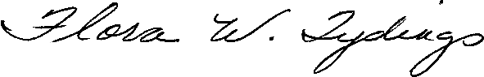
President of the College
Governor

Chancellor, Tennessee Board of Regents

